8.72: a) The stuntman’s speed before the collision is 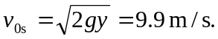 The speed after the collision is

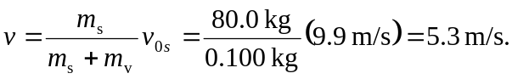

b) Momentum is not conserved during the slide. From the work-energy theorem, the distance x is found from 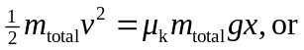

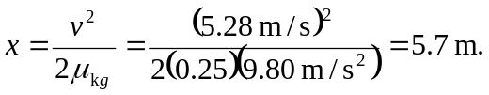

Note that an extra figure was needed for in part (b) to avoid roundoff error.

